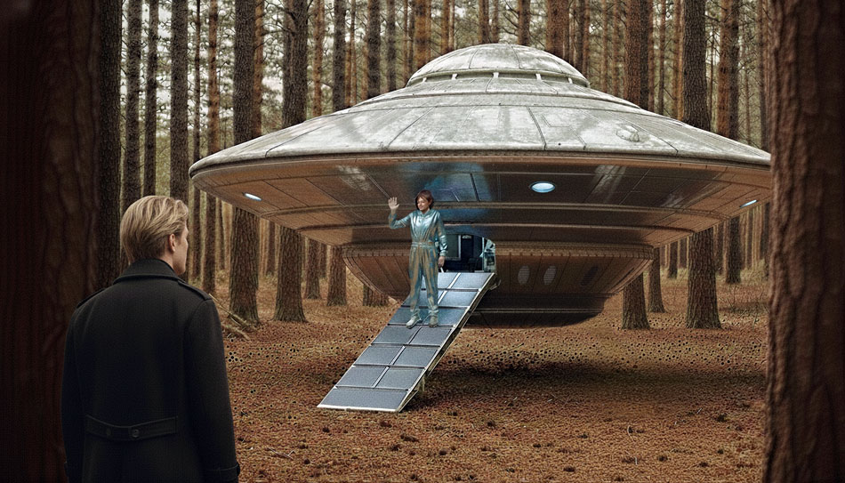
This illustration from short on the case here
This is translated extracts from the German book about their own experiences in the mid 50s; and is no science-fiction!

space travels in extraterrestrial flying spaceships.
RAUMREISEN IN EXTRATERRESTRISCHEN FLUG KÖRPERN.
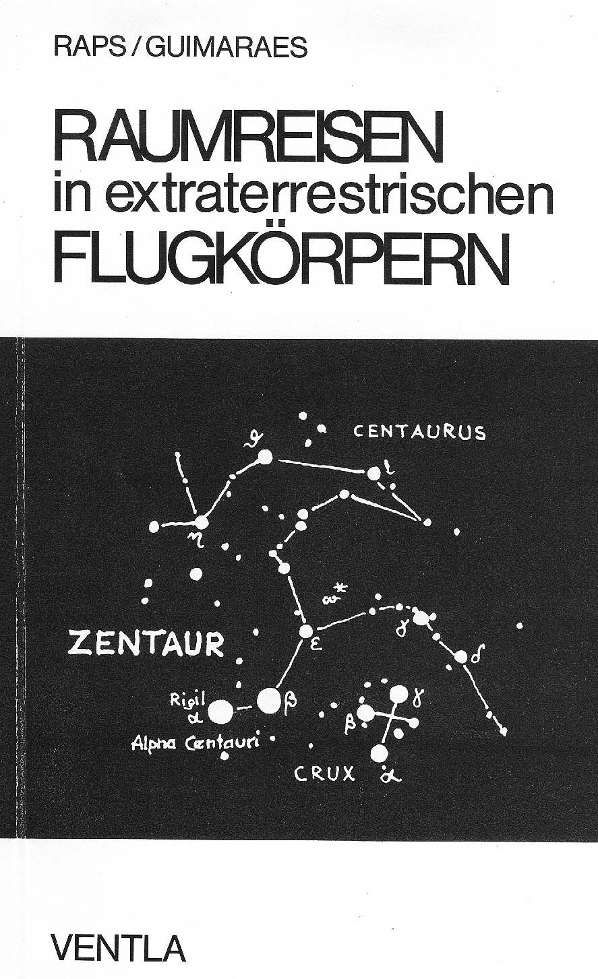
(space travels in extraterrestrial flying spaceships).
ed. by Horst Raps, and Prof. Joao Freitas de Guimaraes
Book from the German Ventla-Verlag, 1973

PROF. JOAO FREITAS DE GUIMARAES
My UFO experience on the Santos coast
Flight in an extraterrestrial object
People from the other star invited to space travel.

48-year-old Professor Joao de Freitas Guimaraes is a respected scholar at the
Catholic University in the Brazilian coffee city of Santos, but the story reported by the Professor of Rights today is so fantastic that no one wants to believe it.
The Dean of the University commented on the professor's narrative with the statement: "Everyone can keep his mind on what he wants, but I do not believe
that Professor Guimaraes is a liar, nor is he suffering from hallucinations or a mental illness.
Professor Guimaraes was silent about his experience for a whole year because he knew no one would believe this story. He finally trusted a friend, and so the adventure came to the public's attention. The professor claims:
"I flew in space in a flying saucer with a foreign star's inhabitants."
thank for help with the translations from David Walsh in England!!
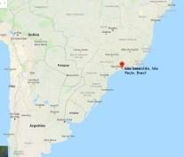
Last summer,(1956?) Professor Guimaraes was walking along the beach of
<< Sao Sebastiao, when suddenly a 20 meter wide and 6 meter high flying saucer landed in front of him. The spacecraft contained two men with blond hair, green eyes, about two meters tall. The professor tried to communicate with them in English, French, Spanish and Italian, but the strangers did not understand his language. The saucer people, the professor reported, then attempted a telepathic connection. "You are on my wavelength." The professor was invited on a flight, and he boarded the flying disc, and telepathically again, the astronauts soon told the professor they had left the Earth's atmosphere, and an hour later the saucer landed Once again - On the beach of Sao Sebastiao, and politely bowing, the people from another star left the professor, and seconds later the flying disc disappeared from sight. Professor Guimaraes, who also reported his adventure on Brazilian television, has not had a quiet minute since. Thousands of inquiries have reached him and he has had to put up with malicious remarks from many people. (UN 17 / January 1958). Hanauer Anzeiger from 21.9. 1957.

Brazilian contact with UFO
The memorable factual report by Professor Guimaraes, Lawyer in
Santos, in TV / Brasil
On the evening of August 27, 1957, Professor Joao de Freitas Guimaraes gave a report of his Flight in a flying saucer on television.
Professor Guimaraes said that he had gone to Sao Sebastiao because he was a Lawyer in military service and had business to do there. Since the court was already closed, he went to eat and then went for a walk along the beach. He does not remember exactly what time, but believes that it was 7:10 or 7:15 in the evening, in May of the year 1956.

The sky was overcast and gray, there was no moon. Since he could not find a dune, he sat down in the sand, his arms encircling his knees, looking out at the sea, which was already dark.

Suddenly he noticed that it was getting lighter on the water, in the strip between the Island Bella and Sao Sebastiao. Just then a jet of water spouted up, so that he thought a whale was nearby. Soon after, he saw that there was a pot-shaped machine that was moving towards the beach. Once there, it ’deployed’ a ’landing ring’ of small balls.
He was particularly struck by the unexpected arrival of this. Two men jumped out of the machine and walked towards him.
Map below of the island Bella and Sao Sebastiao - the strait out to the island is about two km wide
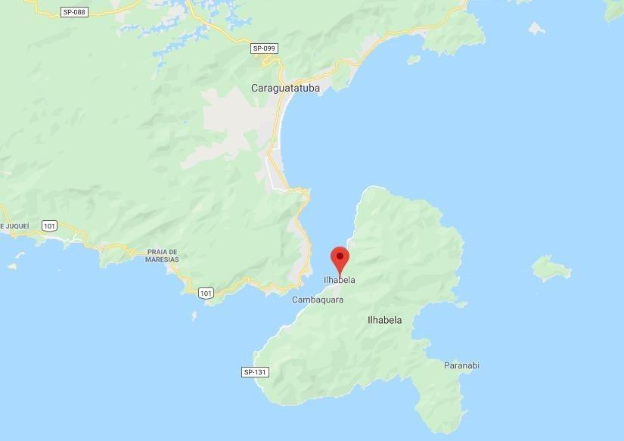
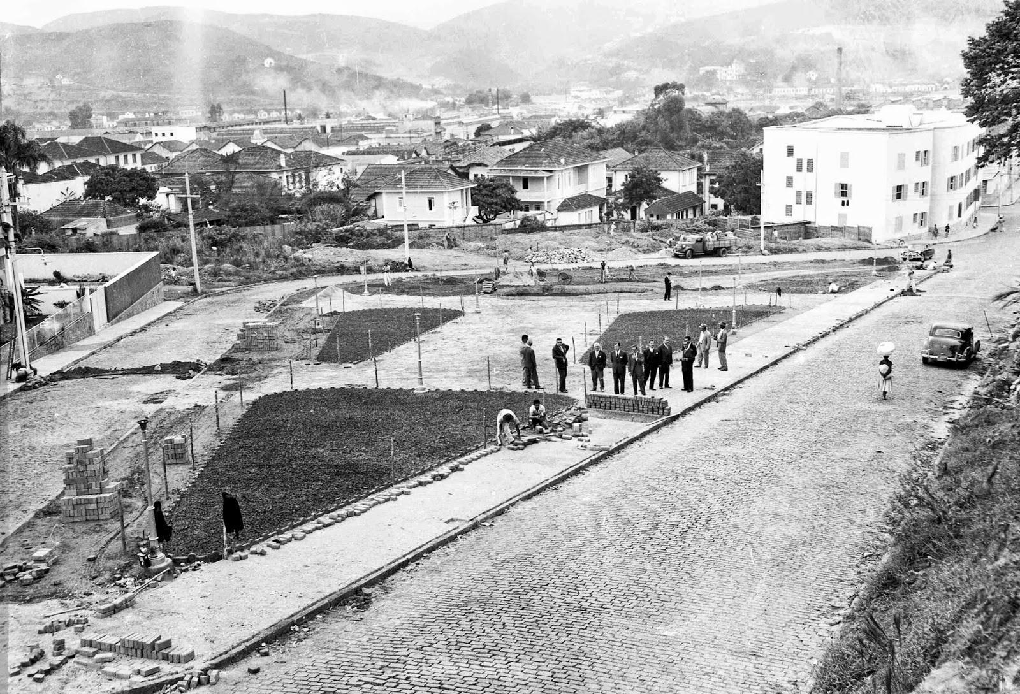
picture of the city from that time-period.

They looked like human beings, at least that's how it seemed to him. He confesses that he was anxious. He stood up and, although he was seized with great tension, did not want to run away.

Now he could see exactly that he was dealing with two tall people (about 1.75 to
1.80 meters tall) with long, light coloured hair, clear skin, and faint eyebrows. They wore one-piece green suits, closed at the neck and also at the wrists and ankles. Their eyes were clear and calm.
The professor asked them if they had any damage to the machine or whether they were looking for someone.
But he got no answer. Then he tried to speak French, English and Italian with them, but again without result.
Then suddenly he had the feeling that he was invited to visit the machine. He cannot say how he arrived at that understanding, but he understood it that way. In any case, it seemed to him that they were conversing among themselves telepathically. He added that he was not a scientist, he did not know these things/people, but he was nevertheless convinced that they used telepathy, though he later remarked that they could communicate with articulate spoken language.

He himself had never been interested in flying saucers. Due to a lack of time, he knew nothing about them. And yet it seemed to him that this machine was such one of those strange aircrafts. Still feeling the invitation, he was filled with the irresistible desire to examine how the craft looked inside.
Already one of them turned his back to Guimaraes and led him towards the machine. He followed without hesitation, accompanied by the second person, so that he went between the two. The first one reached the lower part of the machine and went on-board, ascending on a kind of ladder taking hold of it with only one hand. Dr. Guimaraes needed both hands.
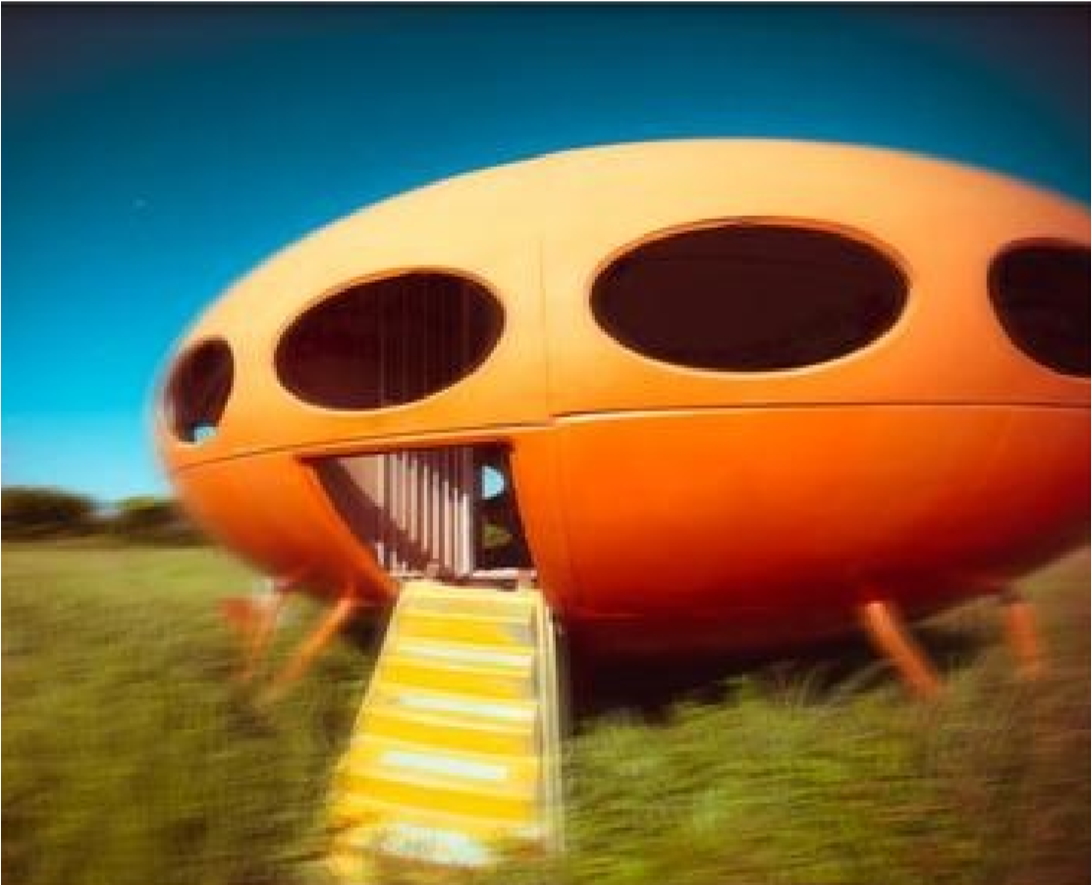
<< Only idea of such a craft with ladder

Dr. Guimaraes could now see that there was still a third occupant inside who had been there all the time. When the second, who had been behind him, came on board, the landing stage, which was previously extended, was retracted and the door closed. The professor said he was in a section of the craft, but he could see that there were other sections as well.

Telepathic connection.
As the machine climbed, he noticed there was water on the hatches as if it were raining. He asked:
"Is it raining?" Then he telepathically received an answer from one of the men on the question as: No. The water comes from parts of the machine which rotates against each other. Around the machine ran a jet filter tube, which created a semi-vacuum in each part.

Through the hatch, Guimaraes saw above the earth a deep dark zone where the stars were extraordinary clearly visible. In the alternating dark areas, the stars had a special shine. Later they crossed a violet layer, later another one. In the first band/zone he felt the machine rapidly swaying back and forth. This made him nervous, when he also got the telepathic information: "The machine has just left the atmosphere of your planet."
During the flight, he asked the occupants where they were from, but he did not receive an answer. He knows not why they did not want to say so. When he knew that they was already outside of the Earth’s atmosphere, he was both amazed and terrified. At the entrance he had noticed a round instrument, on which three highly sensitive and constantly trembling hands moved. At the moment of leaving the earthly atmosphere, they stopped vibrating. Later, Guimaraes was told by one of the member of the crew that the machine was navigated by registering the intersecting magnetic force lines. The passing space bodies, differently coloured, and the fast-moving clouds, iridescent in all the colours of the rainbow, offered him indescribable spectacle.
At the return he noticed that his watch had stopped. That's why he could not know or exactly indicate how long the flight took, but he estimates it to be 30 to 40 minutes.
He then left, going home and felt inclined to tell his extraordinary experience to everyone, but initially kept it to himself.
It seemed to him that the crews of these aircraft were probably carrying out investigations on our earth, and he had the impression that they were urgently warning us of the dangers that threatened humanity. (this was in 1956)
In the opinion of Professor Guimaraes, mankind on Earth behaves like wild animals. Man could be born well, but according to the present Earth conditions they degenerate. There are scientific experiments carried out without the necessary care, and the criminal use of atomic power increase the ionization of the earth. Moreover, it causes the shattering of the layers in our Atmosphere that filters out dangerous rays. If in the future, we don’t take more care in dealing with this, we will all suffer the consequences of these explosions.
(as were also warned about in many other contact cases. for example this one:
link as well as thru the Semjase contacts from january-75. Nordic link)
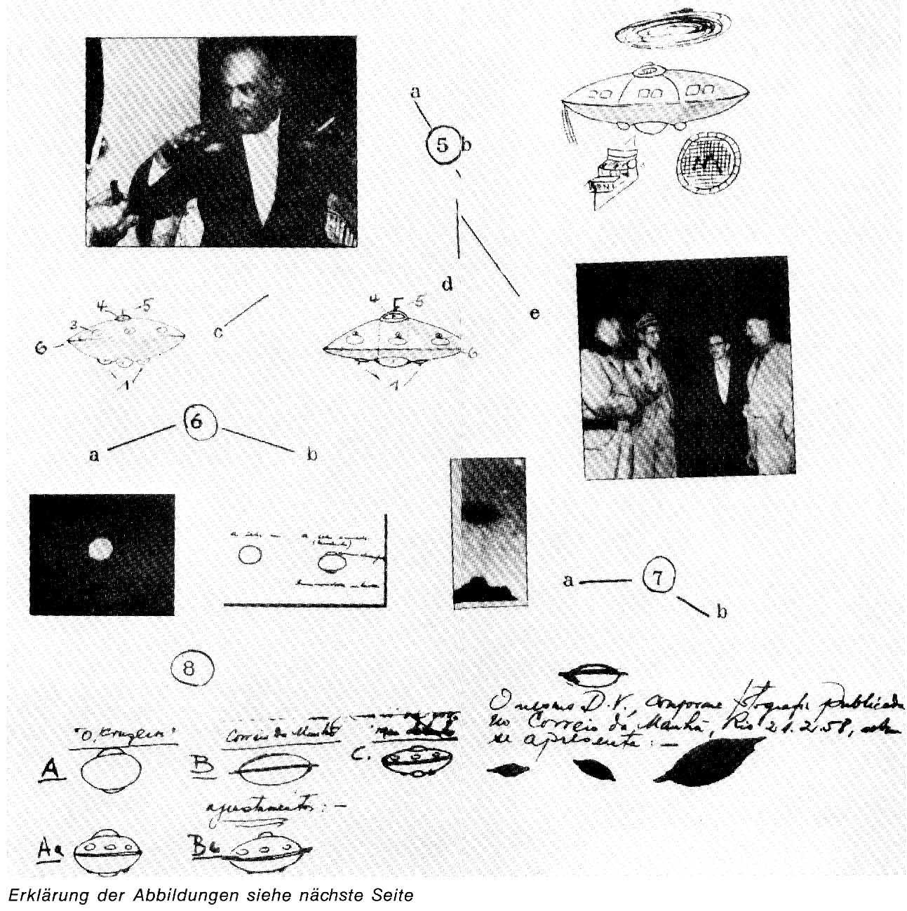
For an explanation of the illustrations, see next page

What’s happened since then?
Again the professor explained that the event itself, took place about 14 months ago,(1956) and that he first of all, with the exception of his wife, had never talked to anyone about it. About six months later however, he did raise the subject of flying saucers to a judge in Sao Paulo, Dr. Alberto Franco, and speaking as well to an old lawyer there, Dr. Nilson. During a meal in the Association of Lawyers, he saw an aluminum pan and made a joke about flying saucers. His colleagues suspected that he must know something about it, after talking about it so much recently. Later, Guimaraes recounted the experience to his friend Dr. Lincoln Feliciano whose article then aroused so much attention.
Since then, Professor Guimaraes had no peace. By all means interested parties sought to get hold of him. Although most visitors were friendly, it was not possible for him to explain exactly what he saw.
For example, if someone is on a strange journey for the first time in a machine powered by compressed air and should later attempt to describe it to others - who have no idea of the principle involved – it could not be adequately explained.
Professor Guimaraes further stated that he was by no means the first terrestrial man to fly in such a machine. He said that since his flight, he had read a whole series of works on the subject, in which detailed experiences, similar to his, were described.
Asked if he had felt bad during the flight, he replied that he had not felt very well as the machine departed and landed again. He would have pain and cold in his Poor legs, but he attributed this to his nervous tension.
He further stated that another meeting with the crew of the machine had been planned for 12 August 1957. Asked how one would have agreed to arrange this date, explained Guimaraes that during the flight a zodiac had been shown to him in which one turn equated to a year, and a multiple repeat of the eighth sign meant that Month August. On being questioned about what prevented him from keeping the appointment, he said it was not possible for him.
A whole group of people had wanted to attend the interview and it would have caused a sensation. Besides, he'd lost almost all of his friends by now, and a FAB official asked him not to keep the appointment. He said that the Luftwaffe/air-force planned to deploy jet planes and if only one of these machines came in contact with the saucer, it would have caused a serious incident.
- Figure5a
Prof. Joao de Freitas Guimaraes demonstrates the event on the beach of Sao
Sebastiao, as well was reported in many daily newspapers of the country when he gave explanations to numerous reporters.
- Fig. 5b
His sketch of the UFO with which he flew. The disc with the three doors of the magnetic Field. Below (r) floor plan of the round bench in the cabin and the circular movement (top) of the central shaft.
- Fig. 5c
Further sketches of the flying object by Prof. Freitas (diameter 20 meters, height 8 meters). Fig. 5d
Sketches showing the details of the functioning of the shock-absorbing landing balls (1) (after the Professor's assumption during the flight) with the command cabin (4) and the antenna (5). Portholes (3) and tube (6) for movement in the atmosphere, which filters the rays. Fig. 5e
Major Paulo Salema and squadron commander Cid vieira de Almeida(SBEDv, Bull. 21) of the Brazilian Air Force Base Bocaina at the Site visit on the beach.
Fig. 6a UFO shot by Jorge at Alto de Boa Vista (Rio de Janeiro district), July 27, 1958.
The same in vivid red paint ("O cruzeiro", August 16, 1958), seen by Attorney
Dr. NiloAlves de Moraes; it was of a dark gray color and showed with the Feingias seen right sketch) additional circles, as if shaped by a propeller.

- Fig. 7a
enlargement of the Trinidad UFO, which was important because of the Similarity to the object of Prof. Freitas, who was invited on board the ship Almirante Saldanha da Gama, from which eight photographs of the UFO by the on-board photographer Almiro Barauna were taken (see SBEDv, Bull. 16).
Fig. 7b Sketches of four different phases of the UFO in flight Upper Trinidad by Prof. Freitas Guimaraes, by courtesy in the "Morgenpost" (Rio, 21 February 1958) and in the Abendblatt (Sao Paulo, February 21, 1958,1. Issue) appeared.
- Fig. 8
Comparative study with three flying saucers: A = Alto de Boa Vista, B =
Trinidad UFO. C =Disc near Sao Sebastiso. With kind permission of Prof. Freitas de Guimaraes. You can find superficial similarities of types A and B with that seen by the professor (C) by comparison.(SBEDv, 22/23/1961) Prof. Joao de Freitas Guimaraesln UN No. 17, January 1958, we published the sensational message:
"Flight in extraterrestrial object " by the then 48 year old law scholar Prof.
Guimaraes from the University of Santos. Here we publish a non-routine interview between Dr. Walter Bühler, who informed the participants of the "5.
International Conference of Friends of UFO Research, May 1963, in the Kurförstl.
Castle in Mainz is known (see UN 83, July 1963) and Prof. Guimaraes. This authentic report confirms the experience with important details from the mouth of the Contact.

DR. WALTER BUHLER, Sao Paulo / Brazil June 25, 1961.
Question 1:
In "flying saucers" a variety of forms seem to exist? Is it possible that one form or another is identical to the one you encountered in the Bay of Sao Sebastiao?
Answer: Yes, I know that the Flying Saucer flying over the island of Trinidad from the photographer Almiro Barauna was recorded, identical to the one described by me. I saw that when I was invited by Dr. Vancome aboard the training ship "Almirante Saldanha da Gama".

I've been on the ship for four hours, on that day. Dr. Vancome showed me six Photographs showing the course of this "Flying Saucer".
It showed the photograph of a UFO taken in a district of Alto de Boa Vista as published in Rio de Janeiro and also published by "O Cruzeiro" on August 16, 1958, identical in shape to the UFO I met in 1956 in the bay of Sao Sebastiao.
On 12 August 1957, another contact with the crew of a UFO was arranged, and this Event became known to the public three weeks before. I also made a drawing about that UFO I’d seen a year earlier. When I also made a drawing for the Brazilian Air Force, I was told that they had similar images in their files. A UFO image that was formally identical to mine. It was also explained to me, I should not go to the meeting I planned with this UFO, because the Brazilian Airforce would order two squadrons of fighters there. All this was communicated to me in the presence of a civil servant, a public notary, from the Bloc 5 of the city of Santos, a man named Dr. Gabriel Alco, and his brother and my own son.

Nevertheless, I made the decision not to go to the meeting because the day before the mother of my father-in-law, was dying, and so was myself tired of the day and night- interviews with reporters all over the country, yes was completely exhausted, besides, I knew that a great crowd would surge to the meeting place, and I also knew that this UFO had been in Sao Sebastiao in the bay of Paraquecaba and these people gave testimony on television. The TV station TUPI also mentioned the names of other people who were present.
It was even a tape recording of the telephone conversation on the Radio Cultura of Sao Paulo to the TV station TUPI. When he visited the latter with this tape recording, they denied everything as expected.
Question 2:
What you have told me now, why did not you say all this to the press or why did you not publish it yourself?
Answer: I actually told a limited number of people, but I have not had it published, because I found indifference in many; on disbelief in almost all. I came to the conclusion that only a few thought it worth investigating, though it was of the utmost importance to me. It was announced that whenever I write something, I would only do so to become famous, or to pursue political goals. Therefore I wrote nothing.
Besides, the press tried to twist the facts, to blame others I had never mentioned; all this with the intention of attacking and ridiculing me, to confuse public opinion, and just when the latter had a right to hear the clear facts.
As far as the reality of the facts is concerned, these should be given to people without distortions, without interference of hidden or incomprehensible motives - said to be a correct assessment - otherwise it will be very difficult, but not in our country (Brazil) unknown. I ask why, why not publish the photographs of the UFOs that are in the Register of the Brazilian Air Force, as reported by
Colonel Coqueiro. This publication thus gives the impression of a "collection of known flying saucers” What hurts me most are those people I thought were civilized, but which were incapable of either admitting a stated fact, nor to discuss the possibility. To do so, they would have to accept a pioneering researcher. This contrasts the preconceptions of these people against the reality of facts, ending in derisory laughter. (!)
Question 3:
Is there any resemblance in the description of the cosmos that Gagarin and you give?
Answer: There is a full agreement between Gagarin's description and mine, which
I gave four years ago, that you can confirm with the descriptions the cosmonauts of the Press on April 14, 1961 (1st edit., "Folta de Sao Paulo") - compare the given description or Explanations in the newspapers, later in the
"Nudeo Ubaldino de Metafisica" in "Minismo" published at Christmas in 1959. If someone is very far away from the earth then it is impossible to tell where the sun is; because even near the earth the sun is orange, At about 200 km away, it seems to be golden; looks at much longer distances, you no longer know the colours of the sunlight, you do not know where it is and how it looks, "our sun" used to be such a "soothing" feeling of a good companion for every Wanderer who left our earth. UN 100 / December 1964)
*
Next in orig.book is a short introduction about an involuntary journey on to the planet
Akart, which Arthur Berlet experienced in 1958 - on to this overpopulated planet, from which the earth in the cosmic evolution is only slightly ahead. More on the Akart contact or in german

Arthur's book, “im Raumschiff von Planet zu Planet" or translated as "in spacecraft from planet to planet", "Eight-day planet journey in 1958."
Mr. and Mrs. Berlet born. KAISER, had in Sarandia a photograhic shop with a studio. His grandfather's name was Johann Berlet. His father was born in Thalitter near Korbach, west of Kassel, in 1879 he emigrated with his parents to Brazil in 1885 as a six-year-old. Therefore would have had a North Hessian dialect or accent in the German he learned to speak.
We now hear excerpts from his experience with the theme: "Eight-day Planet Tour
1958". His planetary friends testified to his special interest in Germany and the German language.Because he could talk the Portuguese-Brazilian language significantly better than German, his experiencer report - with subsequent questions and responses - was given in Portuguese, and recorded with the assistance of two ladies - Mrs. Buchbauer (translating his book) and Mrs. M. Feder - interpreting.
Because in the published work that came out of these session, via: ”im Raumschiff von Planet zu Planet" / "in a spaceship from planet to planet" – There are a great many details and personal statements that are all in the book, but omitted here – you are welcome to read and study the book at your leisure – therefore, here are just a few points worth knowing.
In thirty suspenseful chapters we learn that in a remote area near his hometown, there was a mysterious flying object landed. Arthur went to see what it was, but a ray of light shone out from the craft and he passed out, he lost consciousness and was in this way "ufo-kidnapped". Here is a quick selection of the chapter headings of his fantastic experiences illustrated by drawings, maps and photos: Dramatic awakening - Overcoming of language difficulties - Explanation of the incident - One friendly family - comparing the two planets - a city at night
- government decision – a visit to some farmland - A city in the mountains - Sunsteel factory - Like a space ship arises - The planet without money - Very first conversation - Other jurisdiction - travel back to earth - Farewell - The return flight - Look into space - Landing on our earth - Back on the mainland.
Link to intro video: https://www.youtube.com/watch?=MK8GHxP0Pbo
(English) or http://www.youtube-2.net/AlienCultures/ipad/Akart.mp4
https://rune.ws/acart2.html

German contactor/contact person.
At the DUIST headquarters in Wiesbaden 1972. Like many other contactors, Horst
Raps was faced with the problem after the decisive moment of his experiences in
1959: How should I ever make them clear to my fellow human beings or an authority without suspecting paranoia (GeistessTürung) His conflict lay in the impracticable task of his planetary friends, the experience of his Mitbörgern and the "warning" to announce the atomic science. After Horst Raps had come, after years of waiting in detours, to the headquarters of the German UFO Study
Society, had He immediately felt that he had finally "landed" in the right place. During some informative discussions, his first stepping out was the announcement of his experiences for the "10th. Intercontinental International Congress of UFO researchers in Wiesbaden 1972".
Mrs. K. Metzner wrote us at this time:
I've known Mr. Raps for so many years now; he had to remain silent during this time.
We could not tell other people; you would have laughed at him. But I know that his experience is true, because more happens between heaven and earth than we know.
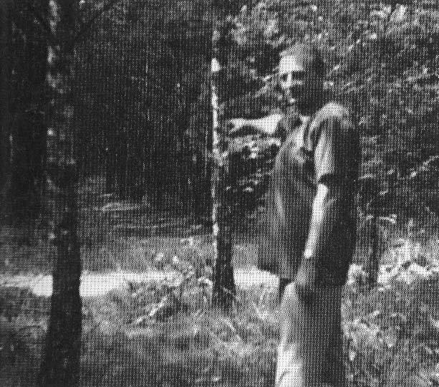
Here was the spaceship in 1959 three times(at L.) landed. The photo shows the total topographical change of the area from the Years 1973, as today there are many trees since 1959. Then was just a large open forest area here of many hundred meters square.

HORST RAPS: “Space flight to distant planetary areas.”

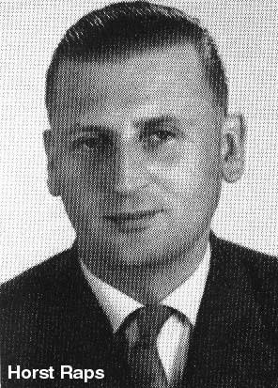Design/draftsman Horat Raps.
Mr. Raps was born on February 13, 1929, as the son of the former school rector of Gumpertsreuth / Bavaria and his wife, the daughter of a graduate engineer in the company of Zeis / Jena. His youth spent in Jena, in 1948, at the age of 19, joined a well-friendly family in L., where he has been living for 25 years.
At the time of the following told below, I was 26 years old. Because of a recent pneumonia, the doctor had prescribed me a frequent stay in the fresh air. So I often went for walks. During a after- dinner walk, the biggest surprise of my life, took place.

The EXPERIENCE/happening.

First meeting with a foreign spaceship.
It was on March 29, 1959. I was taking my regular evening walk.
Not far from my place of residence is a forest area in which there is a clearing. I often stayed at this place because I liked it very much. I noticed that evening at about 8 pm, when I had (passed) the last houses of my place of residence behind me, a light above me about 1000 meters high.
It had the shape of an ellipse and the coloured lights it had changed in quick succession from orange to phosphorous green, turning to white, then blue-white. In the first moment, I expected to see a Meteor. But the steadily increasing size of this object soon led me to understand that this could not be a meteor.
And the object did not fall in an undeviating trajectory down towards the ground, but made several curves until it stood still again. I became curious. With mixed feelings, between curiosity and uncertainty, I went in that direction in a swift run, into the direction where I suspected this thing (to have landed). To my surprise, I found it located close to my often visited grove. When I was about 30 meters from the grove, I heard a soft low humming sound that reminded me of the humming of the telegraph wires - remembered on some frosty night. With a pounding heart and a heavy feeling, filled with excitement, I continued to follow this humming sound, my footsteps grew heavier, my legs felt leaden. I even felt a bit weak in my knees. That's what I felt, but did not know what it was. I instinctively sensed that something had happened here that was not a commonplace occurrence. About 10 meters away, I saw a bright bluish or purple iridescent object hovering about 80-100 cm above the ground, it seemed to float; if I am to describe it correctly, I must say, it stood on bundles of rays! After a while, this object came down even further, until it was about 20-30 cm above the ground. The play of colours stopped, finally, only white beams could be seen.
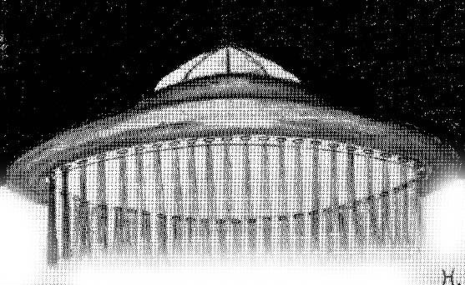
picture of the Floating Spaceship (drawing)

Conversation with the pilot.
I do not know how long I stood there before a double-door opened and a
Stair-like ladder was extended. In the doorway appeared a tall figure, slim and absolutely similar to us humans. This figure wore clothes that shimmered like a rainbow.
To my astonishment, I could hear this figure speaking in the German language*. I went closer. At the same moment, the figure also descended from the ladder with the words: "Excuse me my friend, when I speak to you."
*of course, they must have planned this meeting, and learned some of the language, which they have normally recorded in advance from local radio and television broadcasters, OR that they use advanced translation devices as apparently used in the ITI-BI-RA contact, which happened a few years later in India and Peru, and which we have also NOW developed here on earth. OR they use TELEPATHY, as told below:
My excitement grew bigger, almost unbearable. I said to that man: Why do you speak my language, you are certainly not from here? That seemed to be the situation.
"He answered:" I give you my thoughts and you mine, it's like a ray of light.
You call it mind. In reality, we do not speak with each other, but we communicate with the help of the mind."

- - He said further: "We have come into contact with you to give you a warning of great dangers. Do not look for other worlds before you have your own World in order, and brotherhood and peace is created. There is peace in our world and brotherhood, with neither hatred nor envy and greed. You will need a long time, to be as we are, right now.
- My friend, I cannot stay longer; but if you want, we can come back in three days of Your time, at this same hour - just back at this place."
I said yes.
He asked me to remove/take something from the spaceship, which I did. He then bowed and went into the flying object.

The play of colours began again, the airship rose from the ground like a bullet vertically upwards. How long it took until it disappeared in the sky, I could not determine. The encounter and the impressions that I experienced, left me with amazed and excited, simply no other way to say it. It seemed the elapsed time between my arrival and my return walk, that the whole event had taken place in about an hour.
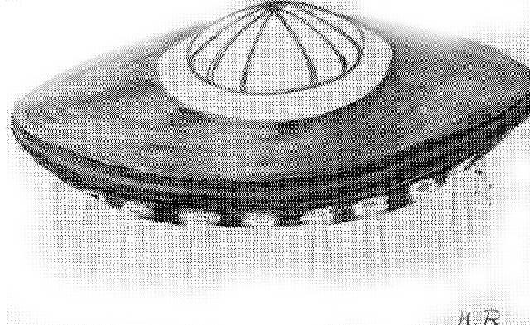
picture - drawing of the landed craft.

Second EXPERIENCE.
The space ship is coming back. With great excitement I already anticipated the next meeting. At the appointment on the third day, I had to wait about 15 minutes before I saw the previously mentioned colours appeared. Now I knew that the strangers were coming back!
I felt calm, but had had a lot things to think about in the last few days. I had come to believe that what I experienced, was a real affair.

The spaceship came closer and landed exactly on the same place as before. The door opened, the stairs were lowered again, and the stranger appeared in the doorway; He did not step out of the door this time, but stayed inside standing, and waved his hand, inviting me to enter the flying object.
Despite my curiosity, I had to fight to ignore abdominal pains, which I got, because what would I suppose could happen if I went to the interior of the ship so defenceless?
-I did not want to show my fear, so I went to the stairs, struggling with myself. The Stranger must have noticed my fear. He smiled and said, "Dear Friend, do not worry, nothing will happen to you." I was glad that I could’nt see my own ‘brave’ figure, as I felt absolutely miserable. A thousand thoughts crossed my mind, if I was taking the wrong step now?

The interior
Finally I was inside.
- Expectant, and at the same time plagued by inner panic - I surrendered to my fate. At least that's what I felt. The stranger bowed once more, described a circular motion with his hand, and said: "We wish you a sincere welcome!"
-It had a strange aspect inside. I saw a round room, about 3 meters high, everything looked like it was made of glass. There was a circular catwalk, about 2 meters wide, with a walkway on the inside that led around and it had in one place a round disc, which looked like a TV screen, just bigger, about 5 meters in diameter. The stranger led me up to a balcony. From there again a few steps higher, in the control room of the flying object.
There I found two strangers. A female and a male person. While leading me in, my companion said, "May I take you to my brother and sister”. I realized later that these people referred to each other as ‘brother and sister’. In the control room there were 4 chairs and in between, appliances, which were to me unknown. The objects I saw appeared to consist of a glass-like vitreous material that I have noticed and mentioned earlier.

Flight through space.
After looking around, my companion led me back into the circular room.
Everything had changed there. The light was diminished except for a twilight, the round glass was illuminated, you could see quick white dots flitting across the screen. The sight of this disc reminded me of a large telescope watching the starry sky.
My companion alerted me to a larger dot on the screen and said, "See, that bright spot is your sun. We are already far from your star system. Do not be afraid, you will return safely to your home planet at the appropriate time.”

He then said: "We are now approaching my home, the Alpha-Centaur system.”

It must have taken a while, I do not know how long, everything got dark on the glass/screen, I could not think properly anymore, everything seemed to be blurry, and everything around me began to change. All the objects seemed to be enlarging, everything looked distorted, as if seen through moving water. I felt a strong pressure on my body. I felt like I was falling apart, as if my skin or flesh was expanding colossally. (It is precisely here that the actual 'dimensional jump' occurs, into the temporary de-materialized state, where one is immediately rematerialized to the cosmic coordinates of the provisional target, the Alpha Centauri system. The distances are illusory, and are neutralized in these dimensional leaps. More on the link about that topic. Rune Ø comment/remark, while I was reading this scan in October 2019 and correcting for scan errors.)
- My thoughts leapt ahead, I felt as if I could anticipate. I thought on a big star that came up to me.
-At that moment the window got light again, the pressure eased, my thoughts arranged themselves again and the environment also normalized to the old
Condition as before. (after the hyperjump - rø.comment)
After a while, when I calmed down, I asked my Companion, what the peculiar state has meant. He owed me the answer by making me understand that it would be too complicated to explain that to me.
- (See BRYANT REEVE, Three Explanations of Space Travel + his book)

On the screen now was presented a very different picture. I saw a whole bunch of large and small points of light that increased in size. In the middle of this, many points of light showed a particularly large point, which my companion called his home planet.
-I saw all the stars that surrounded this planetary body, in all directions, from us outgoing from the field of vision; the spaces between the individual stars were becoming increasingly larger, you could see exactly how the spaceship approached the planet, which is the home planet of my companion.
-Man could, based on the speed anticipated, with what speed the spaceship in space continued to be moving. - In addition came the optical impressions and the Space, silence that you could literally feel. It worked on my nerve centre. A all-encompassing feeling overcame me, of unspeakable greatness, which one could not describe, but can only be experienced.
(similar experiences in the dimensional jumps that the
Erra pleiades made;
link
rune ø.comment.)

The landing.
After a while, we came so close to the planet that we could recognize details on the surface. My companion told me that we were soon to arrive at our destination, the homing-beacon would already have begun to guide us in for a safe landing, as it was able to do. The landing area was a big place, it shone like Metal or ore. It looked as if the whole surface had been cast in one piece, it was mirror-smooth.
- When the spaceship reached its landing place, the door opened, and the stairs were extended again and we went down to the shiny surface of the metal-like Substance.
-I saw a pulpit-like object floating towards us, which held steady before us. My
Companions invited me to board. Without a guide, we floated off. To 300-400 meters, then we had to get off again.

Other gravitational conditions.
We were standing in front of a huge building. It looked like a big dome-shaped hall. My Companion told me to run carefully and as little as possible unnecessary Moving, because the attraction of their planet is lower than ours on the Earth.
- I also noticed that running was much easier, I felt like I was running on feathers.
- After a few steps, it started, I just felt as from the ground – a floating feeling - away. I must have been too strong, my companions had this probably already expected; They pulled me back nimbly, holding my legs, back again on the ground. This sense of being light is hard to describe. You come like a balloon that strives to go upstairs. Anyway, I had to be terribly careful not to make more leaps in the air.
- A station and local transport.
As we entered the hall, I saw many people walking on escalators and was transported away.
-Here I could see many types of human types. Some looked similar to 'our' Chinese and Japanese. It was a colorful mess. My own person did not attract attention, I think I was not (specially) noticed. We also went on one of these platform -walks and rolled away.
After a while, it then went downwards, about 20 feet deep into the underground.
We ended up again, on a platform-like footbridge.
There drove, some like brisk objects, similar to our subways. The Compartments again had armchair seatings from the same glassy -like material.
On one of the walls was a screen that constantly lit up still new characters, which left. The fonts was similar to the Chinese fonts.
After a few minutes we arrived, at our seemingly goal and the train stopped and we got out. On a staircase we rolled up again. Arrived there, I was amazed. I was expecting a city based on earthly patterns. That was not so.
Buildings in flower arrangements.
There was a wildpark-like terrain, with trees and shrubs. Flowers like Growths, which was arranged on the ground in star form, with an indescribable aromatic scent. This gave me a fantastic eye candy, with a plant world not comparable with such on our earth.
- In the area were cube-like buildings, in different shades. My companions went to one of these buildings. It was white and bigger than the others.
-In the house of the "prince"/leader.
We came into a hall-like room with tall pillars of material that looked like ours on earth: of rock crystal. In the middle was a semicircular table and in the background some armchairs. Before the table were small stools. The middle armchair behind the table was larger than the others, also made of the same vitreous material as I already had seen in/ from the spaceship. The other chairs had different colors.
-My companions spoke German and told me that we would be introduced to their chief. He is called as we used to call a chief on earth: "prince".
Urgent speech.
When the so-called prince appeared, I was introduced as usual. No handshake just a bow, a smile and a welcome. He invited us to sit in stools. Then only after we had sat down, did the Chief sit down.
-At first I did not understand anything that my companion spoke to his 'prince' about, it was only a few words. That was the first time I did not understand anything. The people were for me most unusual.
Then the head turned to me and said: Stranger, we would like to help Earthlings, but you do it to us especially difficult. You are not peaceful, so mentally and technically very backward. The main reason, the missing peacefulness, as you disregard, so you can not make rapid development. Only with unity and freedom, not through hatred and Greed, can high goals be achieved.
If one has not yet created a unity in one's own 'local place'/camp one still has to go through many ways of purification. Just like a Gemstone in the raw state, must go through many stages of processing, until it reaches its finished full glorious level, similar must the human race rise by its own power and own work. Because you Earth men are still far from it. "
He further said, "You will need many more earth years to come close to these levels/steps (said in -59), - to reach the stage that separates you from us. What you think of in your progress in spiritual as well as in material terms, is the pointless combat, wars and again Wars. The wars hinder you most in further training of your civilized ascension."
Finally, he said, "We want to help you and will help you if you Earth man earnestly strikes yourself and does execute everything to the good in every form . "-
After this conversation, the head said goodbye and said he wished us Earthlings would make our own a few steps higher. I should stay (in contact -) with them - to look around.
Continues with subway/ tunnel track.
My companions left with me by the building. Then we came back to an entrance,which led us down into the subway, so that we came back with one of the trains. These 'tugs' looked now very different.
Next to the platform was a tubular tunnel, in which was a train, which had a cylindrical appearance and that of the tubular thing was adapted it. This lug had several openings that slide like doors which automatically opened. Behind these doors were again more doors, to which the cylinder train belonged. So you could only enter the train when both doors were opened, first the door of the tube and then the door of the train. -Every time a train arrived, one heard a hiss, as if air from a valve. You could not at first see this train, because it was hidden through this enclosing tunnel.
My companions explained to me that this railway was driven or advanced by high pressure. This transport did not cause any noise, only when it was moving or stopped, could you hear the hiss.
My feeling was that the journey had only taken a few seconds; we had hardly sat down, before we had to get off again.
We were back at a train station, where a big door opened in front of us. Behind it was a room in which we re-entered after the door blew open. One could hear hisses. Then another door opened on the opposite side and we found ourselves in a large hall that looked like an underground ravine.

manufacturing plants.
You could hear several loud noises, which became stronger with each step. My companions told me that we would now come in a custom room.
-After we had gone through some corridors, we came in a huge Rock vault; it was impossible to estimate or determine the height and width of this space. In this vault stood machines that were larger than houses. Between the machines had wide sliding belts that carried many types of objects. In addition to these sliding
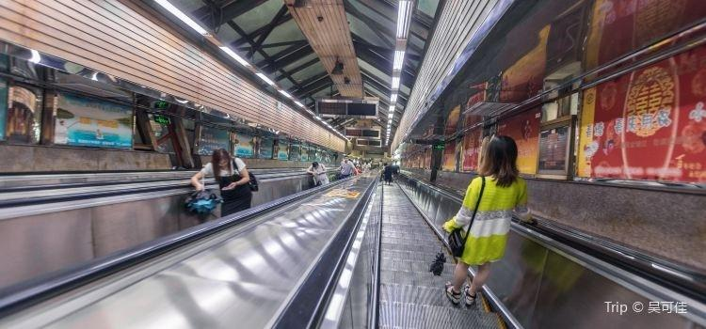
belts were escalator-like catwalks on which people were transported back and forth. (similar idea?>>) You could see how they left the sliding belts on the machines or climbed.
-My companions told me that what I thought was human was not human,but robot-like mechanisms in human form.
People do not work, he said to me. Your job is to monitor these robots and machines.

diet pills.
Particularly interesting for me was an apparatus or machine that was in a rock wall, making something that had to be poured. One could only see the front, the other one was in/against the Rock wall. This front had an opening next to the other from which round leaflets came out in 50-pfennig size.
My companions told me that this Apparatus would produce nutritional tablets. I was given two pieces of it to attempt; they were about the same taste as cocoa and vegetables. That was strange that after a few minutes I had a saturated feeling, as if I just had taken one (big) Meal .
I also felt a tremendous physical strength and a spiritual freshness that I had never possessed on earth.
-When I saw this variety of production - most of what I saw was, of course, incomprehensible for me - we went back to the tube train, that returned us to the starting field.
- Now was the time when it was said to make a goodbye to this unique beautiful and interesting planet.

return journey.
The spaceship took me back to Earth. During the flight, it raided me such a weariness that my companion me, as I had at the starting point of this travel, so when we arrived again in my Hometown, they had to wake me up. My companion said to me: "If you like, we will gladly take you back."
We agreed to meet again, according to Earthly time, in eight days at the same time and same place. -
This trip and the visit took the period from 18.30 to 3.00 clock in the Early: 8 1/2 hours.

Third EXPERIENCE

Second flight to the Centaur area.

Eight days later. -
When I was back on the planet of the Centaurs, they invited me, into contact with the humans of this planet. -I was taken to an area with an 'air-glider', which will remain unforgettable for me.
From the glider I saw a blue at a distance of a few kilometers, a Mountain range. As we approached, I discovered round, funnel-shaped Buildings at the foot of these mountains , but in the reverse funnel shape, so tapers up, and inserted therein were prefabricated Dwellings with terrace-like gradations, with plants and trees. My companions told me that these dwellings belonged to the general public. You could choose an area that suits you best and also a suitable Habitation (house/flat-type?/R).
You stay there just as long as it pleases you. -
If one is fed-up with the area there, you look for a different area and a different habitation to live. -
Economic, educational and social structure.
Since there is no money or distractions on these planets, everything is completely, fully available for everybody.
-Breaking-crimes as on earth, was impossible because of the freedom of the occupants. If someone needs anything, as clothing, etc., they goes into the distributor cities and get whet is needed.
(this is just what the cosmic clear-sighted, danish born, Martinus wrote about 100 years ago, in his cosmic analyzes, in which he described, among other things, how he
"saw" the future society on earth to be in 500-3000 years. rune comment. see www.martinus.dk + see also rune.ws/moneyend.html )
-I see who these people are, seemingly completely uneasy, their living conditions was happy.
Only one thing struck me, I saw no kids around, as it is common with us on earth. I then asked my Companion. They told me, children was not to see; it gives them educational centers, to which the children are until they are mature.
They were not re-educated by the ‘humans hand’, but by highly qualified ones, as
Robots created, which had all human traits. Only to individual education would be (-given-) selected human persons before hand. -
- Unfortunately, I could not entertain/see all these "men of the stars". Not all had all these gifts or abilities, in the way of the Spirit, who you call it, as you with me now speak. (suppose they mean telepathy, rø-rem.)
-I wanted to know, for how many years (age) is it usual for you to marry? The answer was they did not marry as we do, because it is not so good for anyone.
(comment rune- as we also see here on earth now with all of this breaking marriages.)
A covenant in the form, we were here have on earth would only be
obstructive/hindrance in the lives of these people. It is even more difficult to feel in the psyche of these people. If I did, Lifetime lead the people before the eyes, I come to the end, then this People only devote to social things.
It's hard to empathize/understand the psyche of these people. If I look at the way of life of those people in mind, I come to the conclusion that these are Only dedicated for people to social issues. They know obligations only in the small measure. When I now saw everything as these people enjoyed their lives, I missed a certain life content; I could not imagine having ones with so few duties can lead a happy life. Maybe I have too little knowledge on them, too short time accordingly, seen.
An alliance (marriage) in the form of how we do it on earths would only be a hindrance in the lives of these people.

Between/-short flights to a neighboring area.
After I finished my 'inspection', they brought me back to the airport. They told me that before they would bring med home, would take me to one of their neighboring planets, and show me (the results of...) how this human race had been playing with uncontrolled forces of nature.
The flight to these planets was he said, thru millions of Kilometers. My companion made me understand, as they had one particular reason, to bring me to this place in the world. Softly: "The inhabitants of these planets, you will soon see, have gone through a fertile stage.
- It's worth for you of Earth, to pay attention, if is not to be experienced
(for you...) as well."

Planet of horror.
There, the Planet came slowly closer and became more obvious from time to time, moment to moment.
- If one could recognize all the details of the planets, our trip would be interrupted.
one of my companions explained to us that it was impossible to say, how this planet would develop further, in the coming times. That means, the planet had as we what here is on Earth said- been radioactive. - These Human races, which was very cultivated, had undergone a cruel fate. They had, like a human case, been manipulating nuclear forces and then lost control. They created nuclear equipment and brought them selves to downfall. - "That, was what you saw", said my companion, "it is what is Remnant of this irresponsible cruel game. "-
What I had to look at, you could hardly change into words. Crumpled and degenerated Vegetation, completely silent from the beings that were once humans, as we were. -
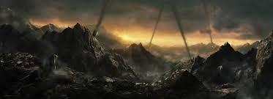
Bodies were bent along the ground, along legs and arms. Partly we saw the skin as poisonous green. Heads, without neck, all in one piece. - Through the magnification disc in the spaceship we could see everything exactly; each movement of these beings was registered.
- some creatures looked like crocodiles. They had a shabby armor around, lookingas if they were illuminated. These beasts had length from a small size to an estimated 5-6 meters in length. -
(more on visits on planets destructed via nuclear weapons and here
There were beings that still had some of human form; they were fighting in explicable ways with the other beings, without even they could use their bodies or limbs into function.
Everything that was in the close proximity, was out of power to do anything. -
These were living, when all culture was destroyed, in hollow housings. My companion explained to me that they can not come into contact with these living beings can, because of the planet as it went through many atomic explosions and so charged with radioactively, and other effects of the compacted field on the (magnetic) belt of this Unlucky planet.

The BIG warning.
Further, he said to me, "For this reason, we have strained to warn you, not to make the same or similar mistakes as those poor beings, who are close to you down there.
- In case of emergency, we could be forced to go against the unforeseen actions.
- Essentially, so-called nuclear weapons make us worry through a possible nuclear war, a planet may be out of its orbit, and could be driven out of the sun-system and into the Universe, which again could possibly make a collision with another planet".
Those were the words that my companion said about the humans and the earths affairs. -Then a man brought me back to earth. The departure was between 18 and 19 o’clock; the return exactly at midnight.
Mother ships.
In space I saw five to six BIG size spaceships (see drawing front or below) inside our our solar system. Their locations were in the experimental station, about which purpose I will report in the next section. From the experimental station were adjacent possible to see "world bodies"; however, there was no occasion to ask because the intersection station was so interesting that I was not able to make any questions of who and where the next planet - except the Earth - was and is.
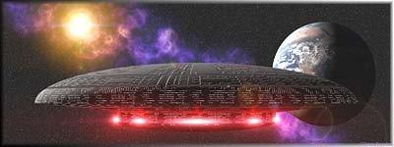

4. EXPERIENCE
Long-distance station with vegetation experiments.
After the second encounter with the Centaurs, I once again had a meeting, somewhat later; I can not remember exactly the date of this meeting.
-Anyway, it had to be between eight and fourteen days after the last meeting. -
They took me back, but not far from Earth, perhaps twice the distance between earth and moon. As I said, I can not say it exactly. -There, the Centaurs had a space station or a base. The same had the shape of a huge ball. The size could have been about a diameter of 2 Kilometers. -

I was told that this station was really a spaceship for experiments.
It was there they tried to cross breed plants originating from our earth, with plants of the Alpha Centauri System. It was incomprehensible to me how they could have made this station! There were trees in a big room, they were pretty
Size in height. They had to be several years old. -I've been told that the
Centaurs have been here for over twenty years in our solar system, and would stay there from the time, since when the first atomic bomb was ever seen on Earth, and had exploded. The Imperium is the name of the union of all solar systems of the Alpha Centauri Territory, and they had sent a survey ship at that time to determine what happened on earth. Since then there was an ongoing surveillance.
(this illustration below was not in the original book)
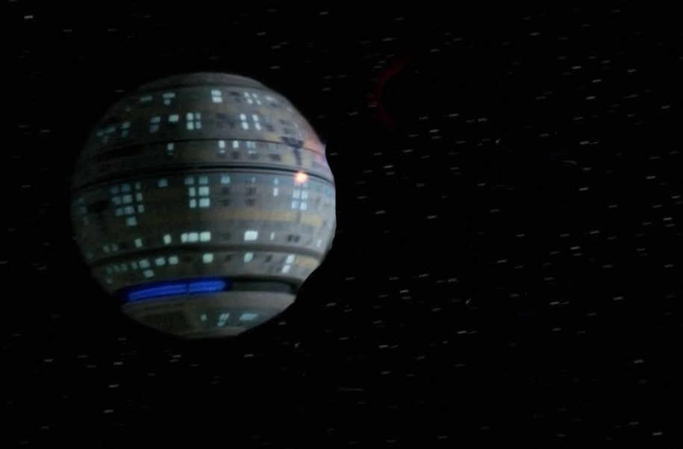
I would like to return to the experimental spaceship.
As I said,the trees were already pretty big. It had been found that the vegetation of our Earth could mix with the similar of Centaurs, to tolerate well. The gas mixture of our atmosphere and that of the Alpha Centauri star probably had small deviations, but just that caused one interesting vegetation. -You could mainly make other flowers that were much bigger and richer in color and scent. - Most plants had flamed leaves, consisting of several Colors, mainly red, yellow and brown. I was told that our plant world is not completely derived from our earth. It had been once with another vegetation before been crossed.

Planet relationship.
It was said: The assumption would be obvious that several millennia ago a connection existed between Mars and Earth. I was astonished when the Centaurs got me revealed that they discovered remains of a past culture on Mars, which bears a great resemblance to the country we call China. Alone the Characters would be authentic. - They also told me that they will soon be called home from here; another group of people would replace them here. This group of people would be closely related to us by blood. -

Race fates and tasks.
I was directed to the sunken land of Atlantis. - These Atlantis people were in for several thousand years, been forced to leave the earth; at that time they had been suspected, Earth would undergo an unfavorable change because it was at that time, they an Experiment dared, one of the moons that accompany our earth there were two or at that time, three, the centaurs did not know it for sure - to use it for another purpose: they wanted to Use one of the moons to make it into a spaceship. This experiment but seems to have gone awry; it was feared that the earth would be affected and would be drawn away. So they decided to leave the earth and move on to another area for search. -
In the Alpha Centauri area, they found a given planet assigned, who was still unsophisticated. They made it arable and created themselves with the help of Empire a new world in which they live now.
-These Atlanteans are the ones who have offered themselves in our solar system for the Monitor task. For the Atlanteans it would be very interesting, to know about their ancestrals homeland, which at that time was so culturally and technically high developed, And was such incomparable with our current culture.
-Over time, the Atlanteans have joined the Imperium of the United Planet Alpha
Centauri, which are connected and today belong to the Empire. This was the opening, these my companions had still made for me.
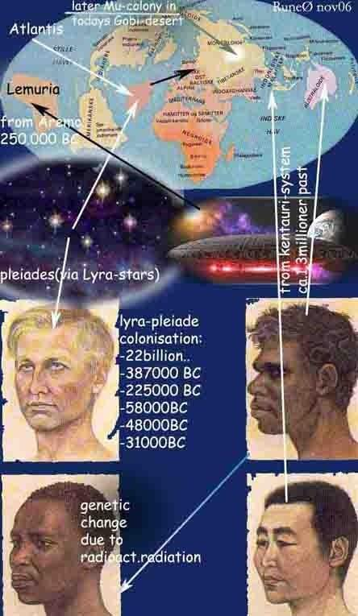
I assume that we are currently being monitored by the Atlanteans. When the hour/ time will come, they will contact us, is still uncertain. Because this path depends entirely on when the United Planets are convinced that the time has come to find our earthly mankind worthy to be taken into the Association of the Empire (or intergalactic confederation). the end.<<Colonization waves acc.to contacts to diff.sivilstions
The dates of the HORST RAPS contacts:
1.Experience: March 29, 1959
Second Experience: April 1, 1959
Third Experience: April 8, 1959 (approx.)
4th Experience: April 18, 1959 (approx.)

an addition;
WHEN DOES THE FUTURE ARISE OF OUR HUMANITY ….or to COME?
Now that you have read my descriptions, you will wonder what to do with it or be allied with this? What do these strange intelligences want with us? As you also heard from my statements, you became one through our Ancestors. The Atlantians attentive that our earth already had a high technology. This gave us the opportunity to visit here to check our ethical level. To this day, we are constantly being watched because of our spiritual and moral level is not yet at the universal laws of our empire. It is not yet sufficient. These foreign intelligences can not intervene in our world affairs because that Universal law provides for assistance only if that particular human race their spiritual level approximated the model of the Empire. So one waits now for many centuries to finally find an opportunity to join us, and to take up into the empire.
Several attempts have been made, to get into contacts with some significant
Governments to liaise; Unfortunately without success. Judging by this point of view at our time and the earth conditions that exists at present, still no hope is to look forward to a relief achieved by this help to life. When this is possible depends entirely on the behavior of our fellow human beings and Peoples of the Earth.
Horst Raps

taken/some free translation from this German book: next- last page here below
https://rune.ws/lydboker/2017uploadAudiobooks/horst_raps_UFO-Kontaktbuch/horst_raps_UFO-Kontaktbuch.pdf

mainpage
and the picture below, which was made with AI about this case recently, is somewhat misleading with regard to the forest here, because Horst himself writes in his book that at the time this happened there was almost no vegetation at the landing site. The picture is great and was copied from a page about this contact - see here


